Memorandum

**To**: Cole Saucier  
**From**: Reno Brown, Morgan Goins, Owen Hamro

**Date**: May 22, 2023  
**Subject**: AERO 356 Lab 2 - Plasma Arcing

Background:  
Plasma is a fourth type of matter that consists of electrically charged particles of high kinetic energy, so that very high potentials exist between ions and electrons in the plasma. The interaction between the Earth’s magnetic field and charged solar wind creates plasma that is often of high enough density to affect spacecraft orbiting around Earth. Plasma can create high charge potentials on spacecraft surfaces, which increases the risk of arcing. Arcing between surfaces occurs when the voltage is high enough to breakdown the molecules in a gap down to ions, allowing current to flow between the two surfaces. This arcing can permanently damage sensitive spacecraft electronics such as solar cells. To test the conditions in which arcing can occur and the effects it can have, we conducted two experiments. For the first experiment, we characterized the power-voltage curve of a small solar cell before subjecting it to arcing in a vacuum chamber. Arcing was achieved with an anode and cathode plate separated by a small distance, and subject to several hundred Volts of electrical potential. Of the four different groups, each one tested a different location and orientation of the solar cell in between the two plates. After we visually confirmed the presence of arcing, we extracted the solar cell and subjected it again to a power-voltage characterization to examine any differences post-arcing. For the second experiment, we used a smaller, pin-style anode-cathode setup in the vacuum chamber. Across the groups, three different anode materials were tested (stainless steel, aluminum, and copper). The pressure in the vacuum chamber was varied and resulting voltage required to induce arcing was noted. As a result, we were able to compile our very own version of a “Paschen Curve”—the relationship between pressure gap and breakdown voltage.

Results and Discussion:

For the first experiment, we collected data from arcing across a solar cell, in four different configurations. Firstly, with the cell positioned in an anode biased position, with the cell facing the anode in the vacuum chamber.

**------ INSERT anode biased – cell facing anode DATA -------**

Secondly, we had an anode biased setup, with the cell facing outward, away from the anode.

**------ INSERT anode biased – cell facing out DATA -------**

Thirdly, we had a cathode biased setup, with the cell facing the cathode.

**------ INSERT cathode biased – cell facing cathode DATA -------**

Fourthly, we had a cathode baised setup, with the cell facing outward, away from the cathode.

**------ INSERT cathode biased – cell facing out DATA -------**

We measured the I-V characteristics of the solar cell before and after arc testing it in the vacuum chamber to see if there were any noticeable performance effects. The results from all four solar cell

--- solar cell and such whatnot—

---Paschen—

For all four Paschen curves shown below, the behavior matches about what we would expect. Starting from about 3 Torr-inch, the breakdown voltage required for arcing decreases steadily as pressure is reduced. At a certain point, however, the breakdown voltage begins to climb up again. This appears to reflect the increasing mean free path of the gas molecules, as for lower vacuums the chance of an ionizing collision between molecules reduces.

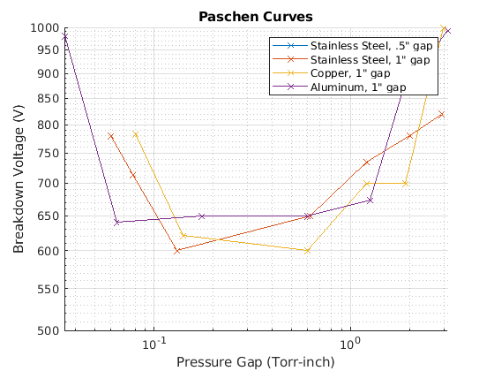

The material selection of the anode causes a noticeable difference in the curves, however.

*The results and discussion should include but is not limited to: the significant findings of  
the experiment, graphs and charts if they support the technical findings, discussion of the  
results, and a short discussion of any error sources that could make your findings  
questionable.*  
*The total memo should be 2-5 pages in length and is written for an audience that is  
knowledgeable about the subject material.*

Conclusion:A brief conclusion is necessary to complete the memo.

References:  
[1] "L2 – Plasma Arcing Lab Manual," California Polytechnic State University, San Luis Obispo, CA, April 2023.